No enough partiontion space for GFS cause ' configuration item parameter fail '
  - Network topology：
Normal topology for ADWAN Branch solution
  - Problem Description：
When install 3 basic components, kernel, GFS and portal, after configure GFS item parameter, it turns out error “Invalid configuration item parameters”
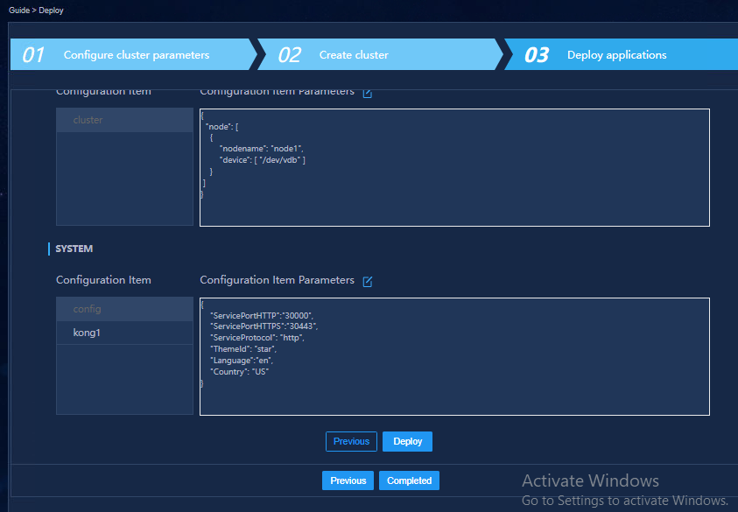
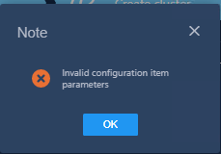

  - Process Analysis：
For GFS parameter, you need configure hostname and GFS partition size.
Execute command： lsblk
It shows there is no partition remained，and the host name is adwan, not “node1”.
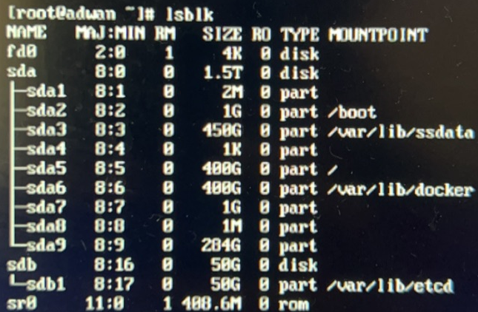

  - Solution：
- add a new partition for GFS
If the server has storage remained from other disk, you can add a new partition for GFS;
If the server does not have, add new disk then.
- Check OS host name
Execute command hostname ,the result is the full hostname
After these two parameter are configured correct, you can continue your next step configuration.

